**Project Design Phase-II**

**Data Flow Diagram & User Stories**

|  |  |
| --- | --- |
| Date | 17 November 2022 |
| Team ID | PNT2022TMID19505 |
| Project Name | IOT BASED SAFETY GADGET FOR CHILD SAFETY MONITORING AND NOTIFICATION |
| Maximum Marks | 4 Marks |

**Data Flow Diagrams:**

The overall percentage of child abusements filed nowadays in the world is about 80%, out of which 74% are girl children and the rest are boys. For every 40 seconds, a child goes missing in this world. Children are the backbone of one’s nation, if the future of children was affected, it would impact the entire growth of that nation. Due to the abusements, the emotional and mental stability of the children gets affected which in turn ruins their career and future. These innocent children are not responsible for what happens to them. So, parents are responsible for taking care of their own children. But, due to economic condition and aims to focus on their child’s future and career, parents are forced to crave for money. Hence, it becomes difficult to cling on to their children all the time. In our system, we provide an environment where this problem can be resolved in an efficient manner. It makes parents to easily monitor their children in real time just like staying beside them as well as focusing on their own career without any manual intervention.

**Example:** [**(Simplified)**](https://developer.ibm.com/patterns/visualize-unstructured-text/) 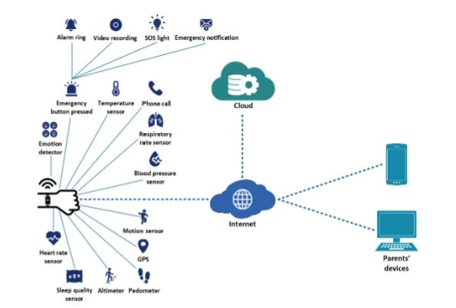

**FLOW CHART:**

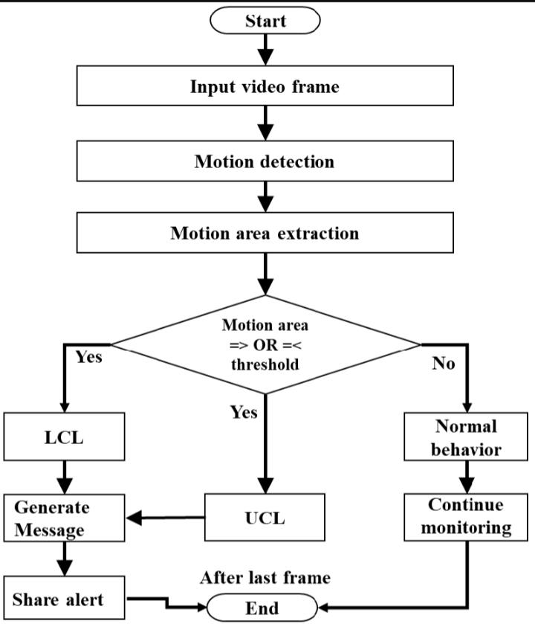

**User Stories**

Use the below template to list all the user stories for the product.

